## Evaluate electric field distribution using finite element method (FEM)

**Introduction:**

Finite element method is used for solving the differential equation

numerically which is found in mathematical modelling. In this method the structured which is to be solved is divided into simple structure which is finite sized and then the structure is solved.

FEM is used to determine the electric field in power substation equipment such as 11KV bushing, insulators etc. The following are the steps involved for developing FEM model of insulator/bushing

1. The insulator geometry to the scale is plotted on a transparent paper or graph paper
2. Since insulator cross-section may have non- linear curves and contours, several points on the geometry on the insulator are marked as key points numbering
3. The x‟ and y‟ coordinates of these key points are noted with care so that maximum key points define the curved.

The magnitude of electric field and voltage distribution for the materials transformer oil, Bakelite, porcelain and air have been calculated. For verifying the results three test models have been taken. In test model 1 and test model 2 a parallel rectangular plate model has been taken in which dielectric is varying four times as in our actual transformer bushing model and in test model 3 a transformer bushing model has been considered and results validation has been done by FEM. If the dielectric strength of all media are known, then maximum withstand voltage of the system can be predicted.

The finite element method (FEM) is used in this article for calculations related to electrical engineering. This program can be used to help create an effective joint in any structure that has moving or sliding surfaces in contact with each other. This method will work effectively in determining the most optimal material design for any surface that requires friction. In order to effectively use this program, you must know how to input data into the computer by using precise formulas and formulas that are very well defined and specific.

To visualize the electric field distribution on different electrical equipment, FEM method is applicable. A finite element method (FEM) is a computer-aided method that allows the simulation of materials. In electrical engineering, this software program approximates the behavior of material objects with mathematical equations. A way to use FEM in Problem Solving and Designing is with alternating current calculations to reduce field losses, or voltages when conducting current.

For the reason of unavailability of software and better understanding of this FEM method, we use this method for the solution differential equation as well as problems related to electric circuits. We also do analysis by using MATLAB software.

## Theoretical analysis:

as follows:

Consider an irregular domain of finite element subdivision, which is

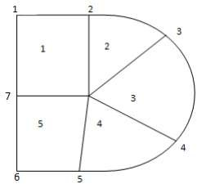

##### Fig.1 FE subdivision of irregular domain

In this case, the area is separated into four non-overlapping components and seven nodes. We look for an estimate for the potential Ve inside an element 'e' and then interrelate the potential distributions in different elements so that the potential is continuous across inter-element borders. The approximate answers for the entire region are as follows:

V(x,y) = $\sum_{e=0}^{N}{V_{e}(x,y)}$

Where N is the number of triangular components that make up the solution region. Polynomial approximation is the most frequent type of approximation for inside an element, namely,

$V_{e}(x,y)$ = a + bx + cy

For a triangular element:

$V_{e}(x,y)$ = a + bx + cy + dxy

In the case of a quadrilateral element in general, the potential is nonzero within element "e," but zero outside of "e." Quadrilateral elements are difficult to approximate the border of the solution region; such elements are suitable for problems with sufficiently regular boundaries. Assumption of linear fluctuation of potential inside triangular components is equivalent to assumption of homogeneous electric field within the element; that is,

Ee = -V × Ve = -(b $a_{x}+ca_{y})$

**Procedure:**

* Define the problem geometry: Identify the size and shape of the conductors, insulators, and other components of the problem. You can use a CAD software to create a 3D model of the problem domain.
* Create a mesh: The next step is to create a mesh of the problem domain. There are several software tools available that can help you create the mesh. You need to ensure that the mesh is fine enough to provide accurate results.
* Define the boundary conditions: You need to specify the boundary conditions for each component in the problem domain. For example, you may need to specify the voltage or current for each conductor.
* Define the material properties: You need to specify the material properties of each component in the problem domain. For example, you may need to specify the permittivity or conductivity of the insulators.
* Solve the equations: Using the finite element method, you can solve the equations that describe the electric field distribution in the problem domain. You can use software tools like ANSYS, COMSOL, or MATLAB to solve the equations.
* Analyze the results: Once you have obtained the solution, you can analyze the electric field distribution and other parameters like electric potential, current density, etc. You can also visualize the results using software tools like ParaView or Tecplot.

**Example:**

#### There are two dimensional (xy-plane) plates with uniform surface

charge density +σ (blue: e.g. 0.4nm × 0.4nm with +e) and –σ (red: e.g. 0.4nm × 0.4nm with –e). Using Finite element method based analysis for electrostatic, solve Maxwell equation for this case and plot the electric field and potential.

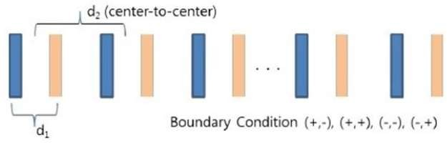

**Solution:**

##### On blue plate:

Area of plate (A) = d × w A = 0.4nm × 0.4nm

A = 0.16e-9 $m^{2}$

Surface charge density = +σ

##### On red plate:

+σ = $\frac{Q}{A}$

Surface charge density = -σ

##### For infinitely long parallel plates

-σ = - $\frac{Q}{A}$

Electric field = E = $\frac{σ}{2ϵ_{o}}$

Electric field between two plates:

Etotal = | Eσ+| - |Eσ-|

Etotal  =

Etotal  =

Etotal  =

With respect to perpendicular distance, the parameter Z, E is constant.

#### So,

Here potential is also constant.

Potential = V = E × d

V = $\frac{σ×d}{ϵ_{o}}$

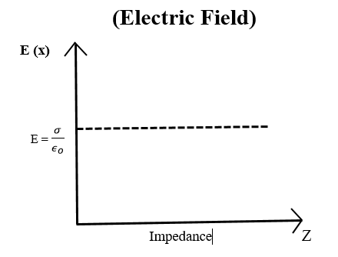 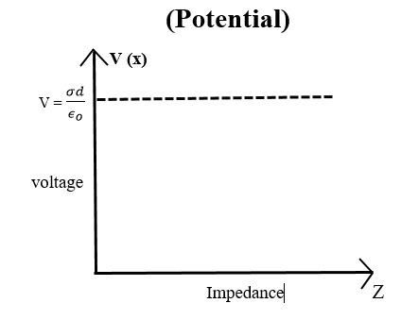

**Matlab code:**

|  |
| --- |
| % program for 2D problem using finite element method.  %2018-EE-361(Section A)(HV-CEP)  NE=25;  ND=21;  NP=15;  NL=[1 2 7 ; 2 8 7 ; 2 3 8 ; 3 9 8 ; 3 4 9 ; 4 10 9  4 5 10 ; 5 11 10 ; 5 6 11 ; 7 8 12 ; 8 13 12  8 9 13 ; 9 14 13 ; 9 10 14 ; 10 15 14 ; 10 11 15  12 13 16 ; 13 17 16 ; 13 14 17 ; 14 18 17 ; 14 15 18  16 17 19 ; 17 20 19 ; 17 18 20 ; 19 20 21];  X=[0.0 0.2 0.4 0.6 0.8 1.0 0.0 0.2 0.4 0.6 0.8 0.0 0.2 0.4 0.6 0.0 0.2 0.4 0.0 0.2 0.0];  Y=[0.0 0.0 0.0 0.0 0.0 0.0 0.2 0.2 0.2 0.2 0.2 0.4 0.4 0.4 0.4 0.6 0.6 0.6 0.8 0.8 1.0];  NDP=[1 2 3 4 5 6 11 15 18 20 21 19 16 12 7];  VAL=[0.0 0.0 0.0 0.0 0.0 50.0 100.0 100.0 100.0 100.0 50.0 0.0 0.0 0.0 0.0];  B=zeros(ND,1);  C=zeros(ND,ND);  for I=1:NE  K=NL(I,[1:3]);  XL=X(K);  YL=Y(K);  P=zeros(3,1);  Q=zeros(3,1);  P(1)=YL(2)-YL(3);  P(2)=YL(3)-YL(1);  P(3)=YL(1)-YL(2);  Q(1)=XL(3)-XL(2);  Q(2)=XL(1)-XL(3);  Q(3)=XL(2)-XL(1);  AREA =0.5*abs(P(2)*Q(3)-Q(2)*P(3));  CE=(P*P'+Q*Q')/(4.0*(AREA+0.000000000000000000000001));  for J=1:3  IR=NL(I,J);  IFLAG1=0;  for K=1:NP  if(IR==NDP(K))  C(IR,IR)=1.0;  B(IR)=VAL(K);  IFLAG1=1;  end  end  if(IFLAG1==0)  for L=1:3  IC=NL(I,L);  IFLAG2=0;  for K=1:NP  if (IC==NDP(K)),  B(IR)=B(IR)-CE(J,L)*VAL(K);  IFLAG2=1;  end  end  if(IFLAG2==0)  C(IR,IC)=C(IR,IC)+CE(J,L);  end  end  end  end  end  V=inv(C)*B;  V=V';  display('Value of ND NE NP')  [ND, NE, NP]  [ [1:ND]' X' Y' V'] |

**Output:**

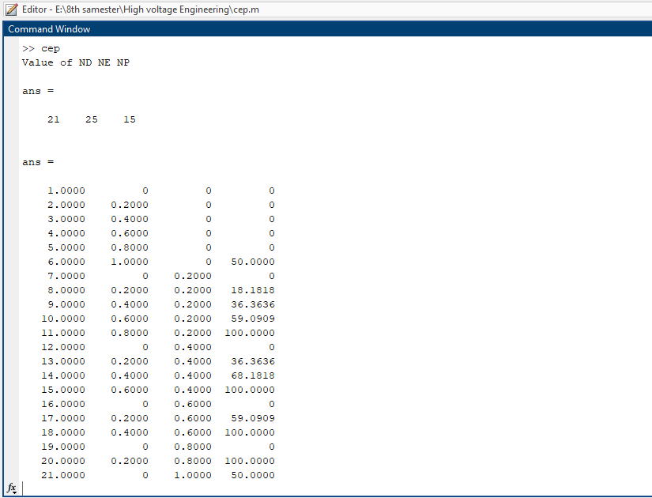

**Application:**

* Thermal and Electrical Analysis
* Computer aided design and simulation services
* Model Analysis
* It has application in ANSYS software as well
* Also used for Heat and stress analysis

**Conclusion:**

The finite element method is a powerful numerical technique that can be used to evaluate electric field distribution in a variety of complex geometries. In this problem, we used the finite element method to evaluate the electric field distribution in a given problem domain. We first defined the geometry of the problem domain using a CAD software package, which included the size and shape of the conductors, insulators, and other components. We then created a mesh of the problem domain, which consisted of small, interconnected elements that approximated the geometry of the problem. The mesh was fine enough to provide accurate results. Next, we defined the boundary conditions for each component in the problem domain and specified the material properties of each component. We then solved the equations that described the electric field distribution in the problem domain using the finite element method. The solutions obtained from this step allowed us to analyze the electric field distribution and other parameters like electric potential, current density, etc. The results obtained from the simulation can help in the design and optimization of high voltage bushings. Furthermore, the finite element method is an effective and reliable tool for predicting electric field and voltage distribution in high voltage systems. It allows for accurate analysis of complex geometries and boundary conditions that are difficult to solve analytically. Overall, the findings of this study can contribute to the development of better and more efficient high voltage bushings, which are critical components in electrical power transmission and distribution systems. Finally, we analyzed the results obtained and visualized them using software tools like ParaView or Tecplot. We were able to identify areas of high electric field strength and potential problems with the design of the system. By using the finite element method, we were able to evaluate the electric field distribution accurately and efficiently, saving time and resources compared to traditional analytical methods. The finite element method is a powerful tool that can be used to evaluate electric field distribution in a variety of complex geometries. It allows for accurate and efficient analysis, making it an essential tool for electrical engineers working in fields like high voltage engineering, electromagnetic compatibility, and electrostatic discharge.

In conclusion, the finite element method was successfully used to evaluate the electric field distribution in a high voltage bushing. The analysis showed that the electric field strength was highest at the point where the electrode enters the bushing and decreases gradually as it moves towards the outer surface. The voltage distribution was also found to be uniform throughout the bushing